My name is ________________________________

LG: I can hear and say the /s/ phoneme. I can write the letter shape for the ‘s’ grapheme.

Draw a circle around the things that begin with /s/

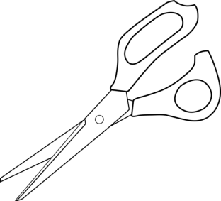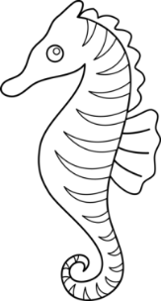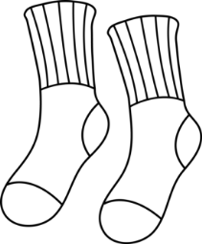

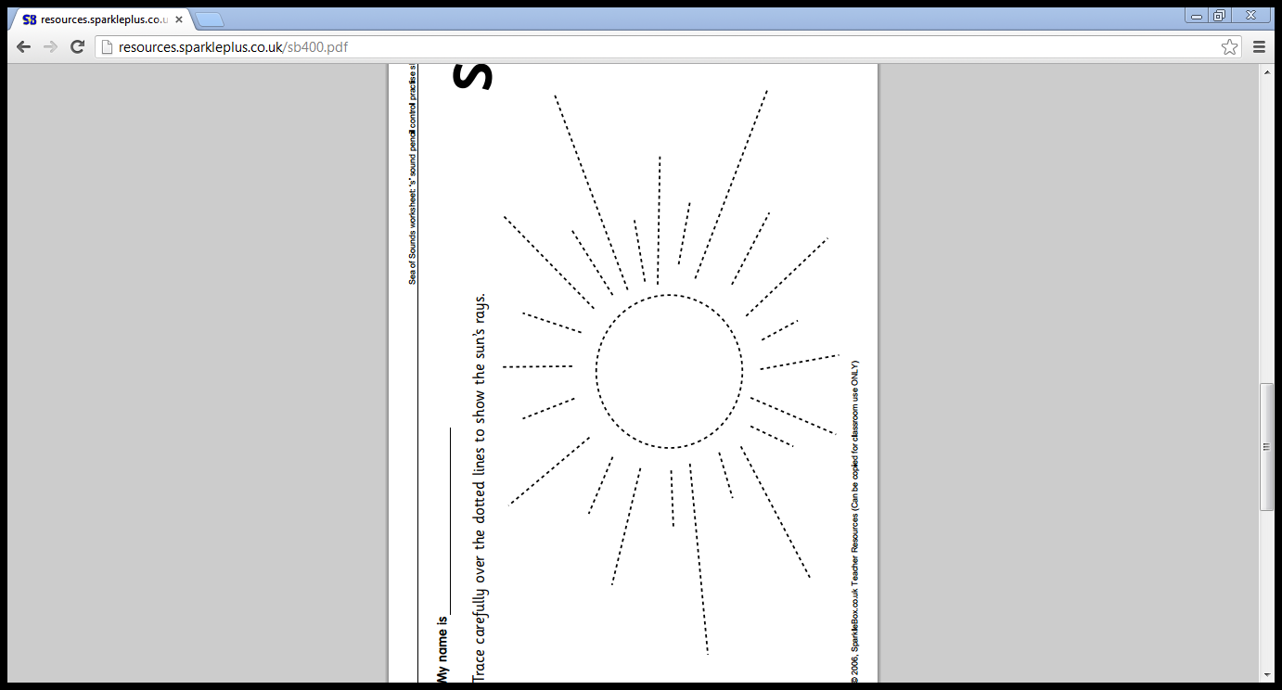

Trace carefully over the dotted lines to show the sun’s rays

|  |  |  |  |  |
| --- | --- | --- | --- | --- |
|  |  |  |  |  |
| s | s | s | s | s |

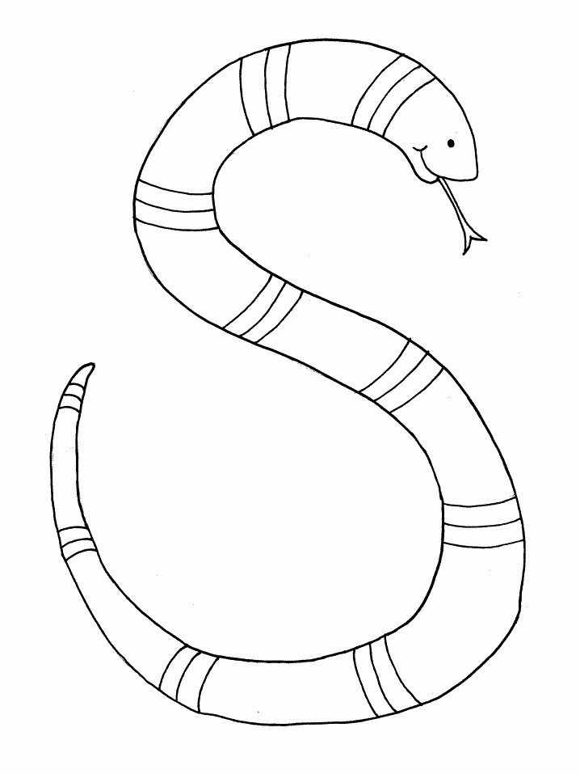

Write the letter shape

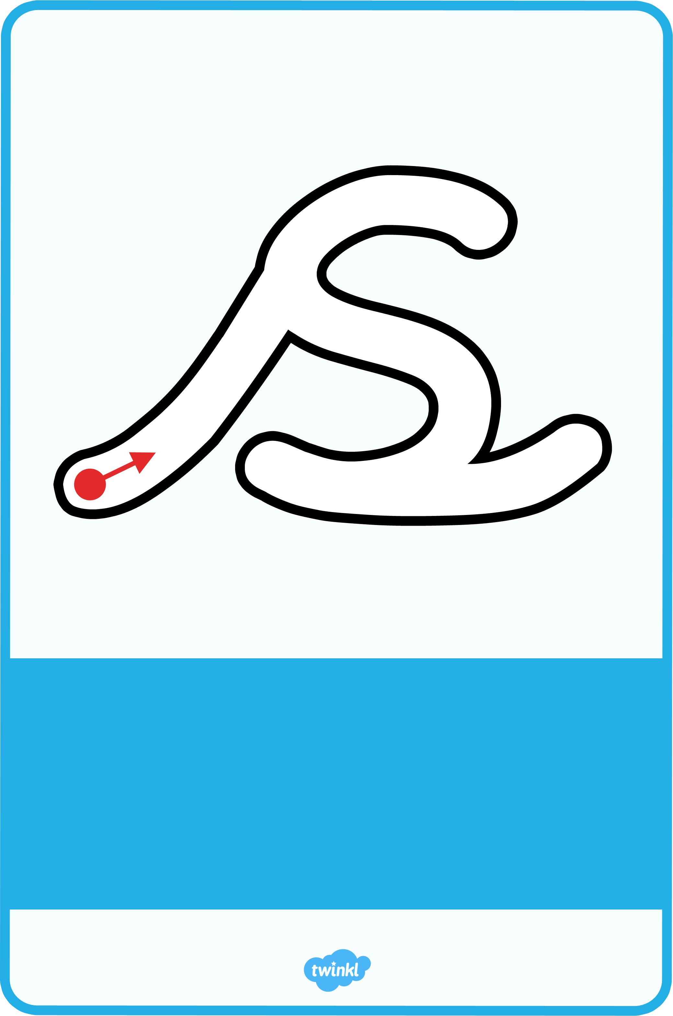

|  |  |
| --- | --- |
| s | 1. **Tune:** **The Farmer’s in his Den**   The snake is in the grass.  The snake is in the grass.  /sss/ /sss/  The snake is in the grass.   1. **Rhyme:** Slide up and over to the snake’s long tongue. Watch out! Slide all the way round to his tail and then across the bottom to make a flick. |

My name is ________________________________

LG: I can hear and say the /a/ phoneme. I can write the letter shape for the ‘a’ grapheme.

Draw a circle around the things that begin with /a/

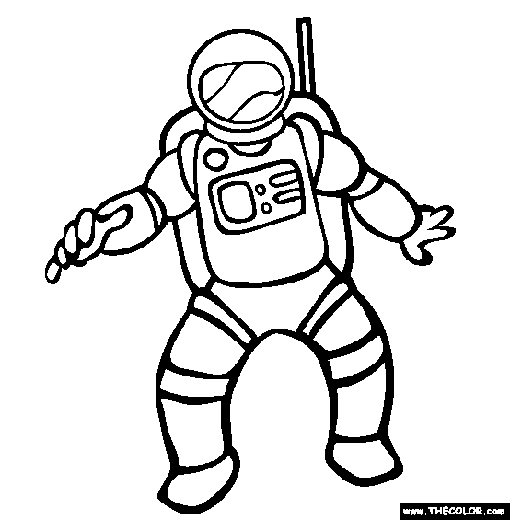

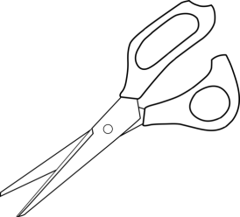

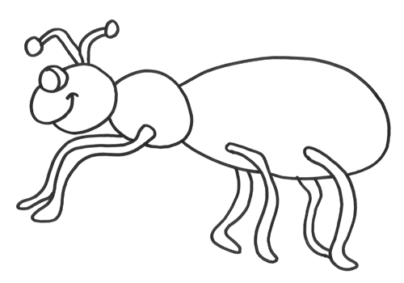

Trace carefully over the dotted lines to show how the arrows fly

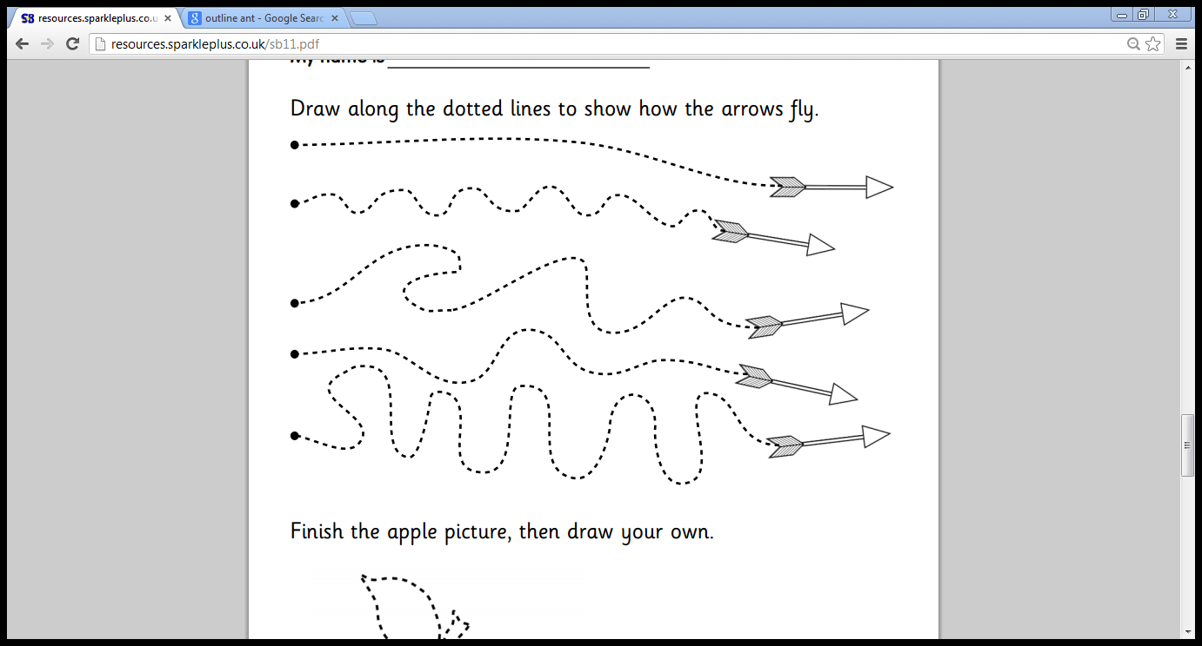

Write the letter shape



|  |  |  |  |  |
| --- | --- | --- | --- | --- |
|  |  |  |  |  |
| a | a | a | a | a |



|  |  |
| --- | --- |
| a | 1. **Action:** Pretend to hold and bite an apple on the right-hand side of your mouth 2. **Tune: Skip to My Lou**   /a/-/a/-/a/ is for apple.  /a/-/a/-/a/ is for apple.  /a/-/a/-/a/ is for apple.  Take a bite like this …/a/!  **Rhyme:** Zoom up to the leaf and back around the apple. Then slide down and end with a flick. |

My name is ________________________________

LG: I can hear and say the /t/ phoneme. I can write the letter shape for the ‘t’ grapheme.

Draw a circle around the things that begin with /t/

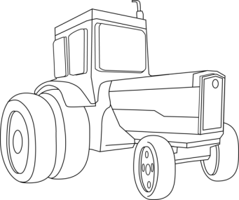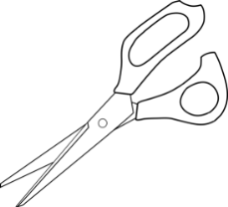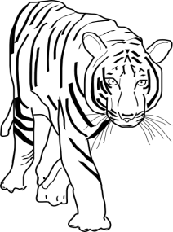

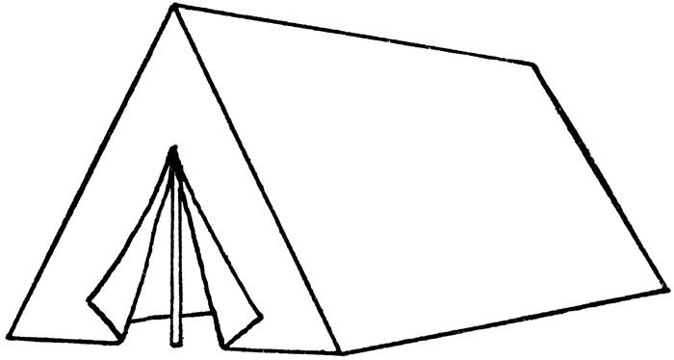

Trace carefully over the dotted lines to show how the turtles swim

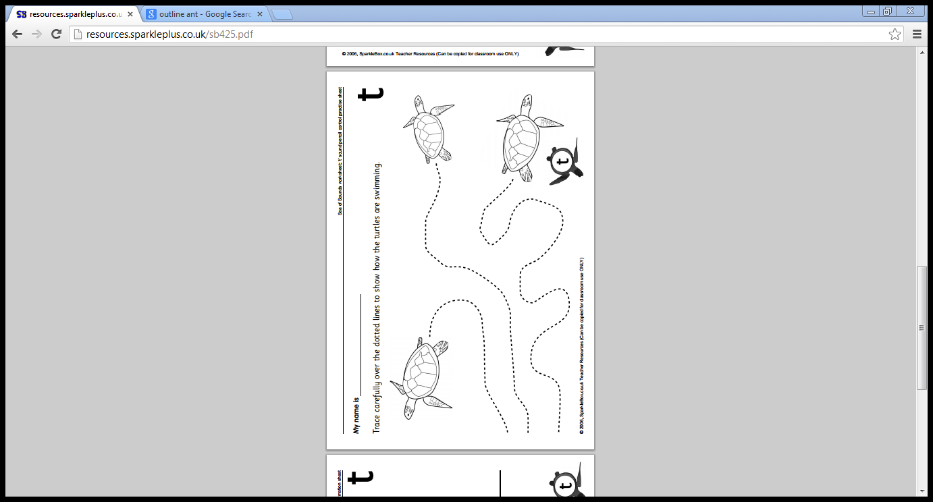

Write the letter shape

|  |  |  |  |  |
| --- | --- | --- | --- | --- |
|  |  |  |  |  |
| t | t | t | t | t |

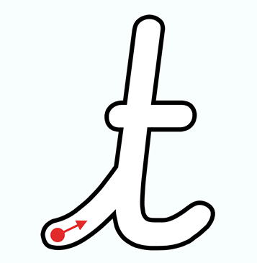

|  |  |
| --- | --- |
| t | 1. **Action:** Hold both hands flat and parallel. Put them up in the air and straight down again to make the outline of a tower. 2. **Tune: The Farmer’s in his Den**   A tower stands tall like this.  A tower stands tall like this.  /t/-/t/-/t/-/t/  A tower stands tall like this.  **Rhyme:** Climb straight up to the top of the tower and then straight back down again. Don’t forget to add a flick at the bottom and cross the turrets. |

My name is ________________________________

LG: I can hear and say the /p/ phoneme. I can write the letter shape for the ‘p’ grapheme.

Draw a circle around the things that begin with /p/

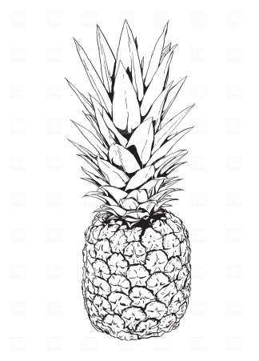



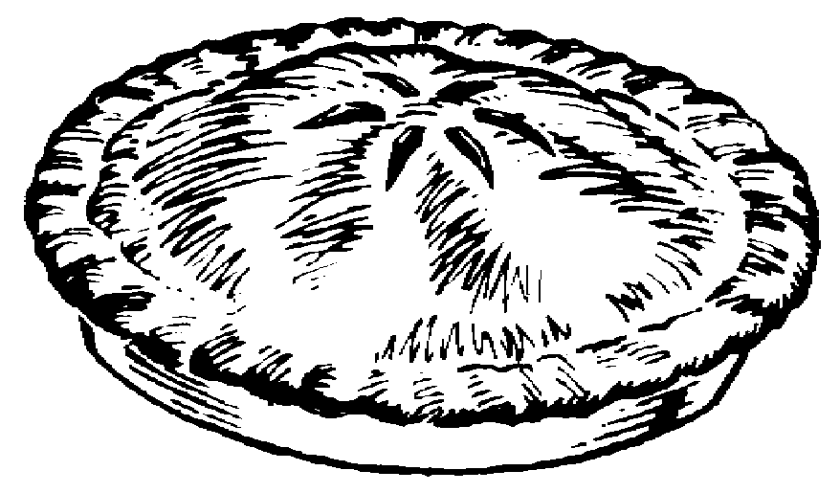

Trace carefully over the dotted lines to deliver the parcels

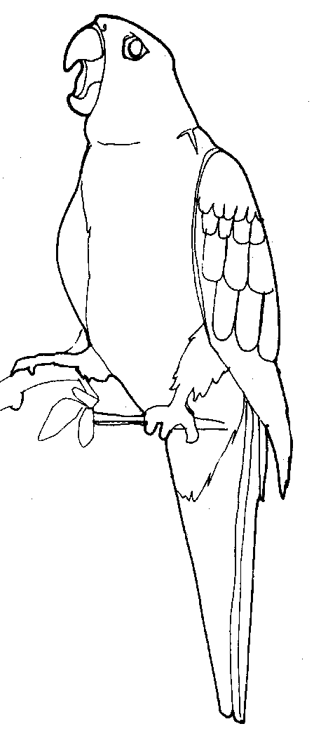

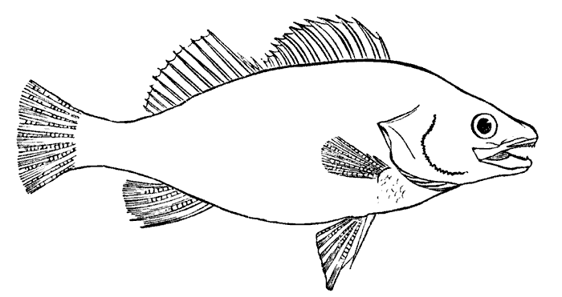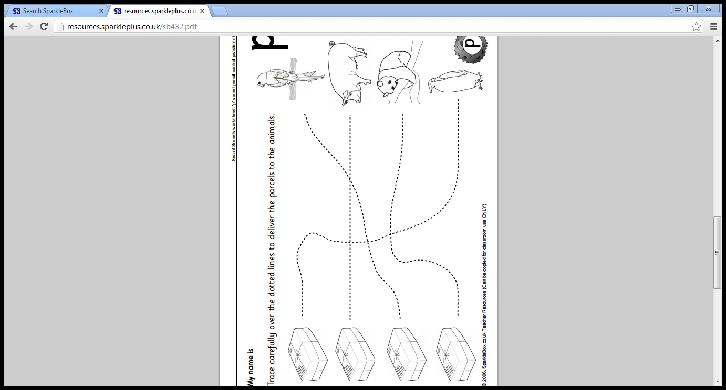

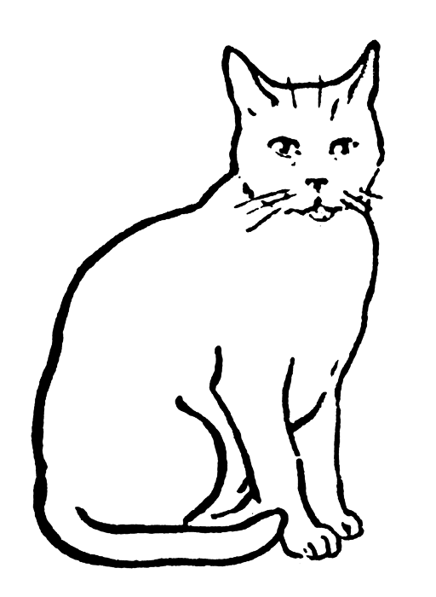

Write the letter shape

|  |  |  |  |  |
| --- | --- | --- | --- | --- |
|  |  |  |  |  |
| p | p | p | p | p |



|  |  |  |
| --- | --- | --- |
| p | 1. **Action:** Put right hand over your right eye and pretend to have an eye patch 2. **Tune: The Farmer’s in his Den**   The pirate wears a patch.  The pirate wears a patch.  /p/-/p/-/p/-/p/  The pirate wears a patch.   1. **Rhyme:** Fly up to the parrot’s head and then move down to the bottom of his feathers. Go up and around the pirate’s head and slide across the bottom with a flick. |  |

My name is ________________________________

LG: I can hear and say the /i/ phoneme. I can write the letter shape for the ‘i’ grapheme.

Draw a circle around the things that begin with /i/

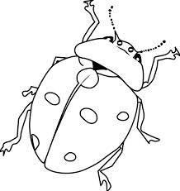

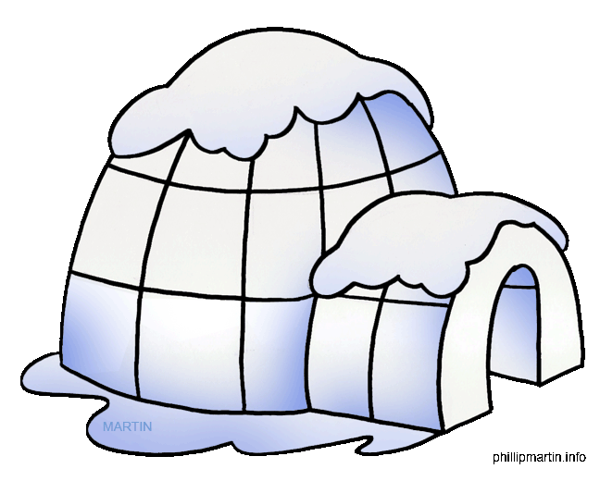

Trace carefully over the dotted lines to show how the insects have crawled

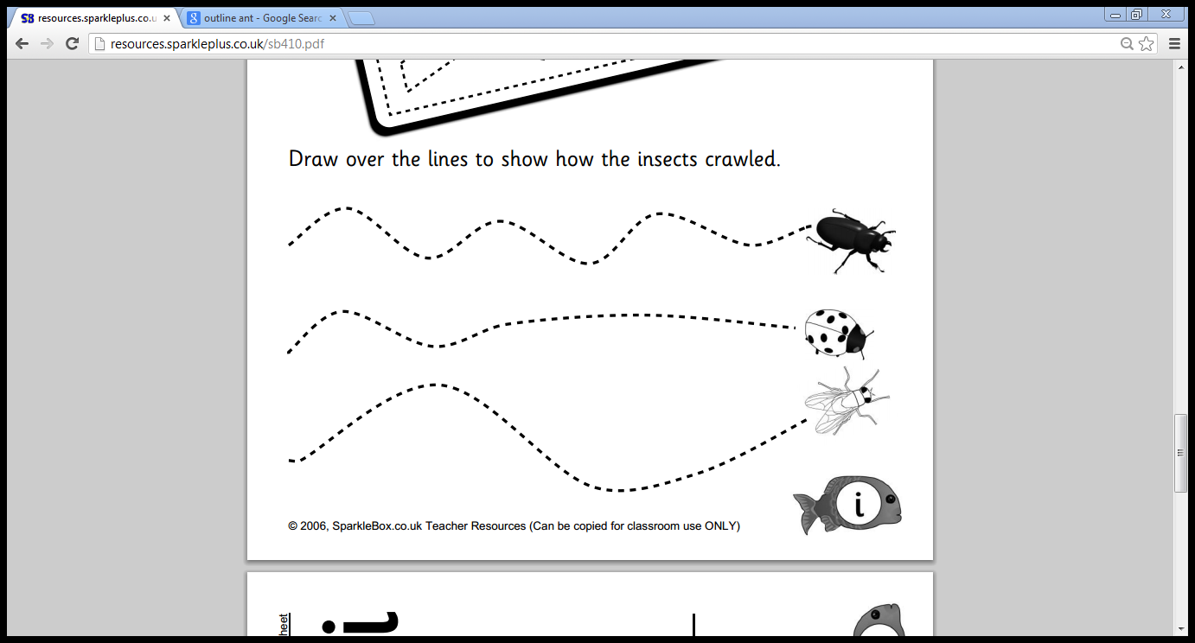

Write the letter shape

|  |  |  |  |  |
| --- | --- | --- | --- | --- |
|  |  |  |  |  |
| i | i | i | i | i |

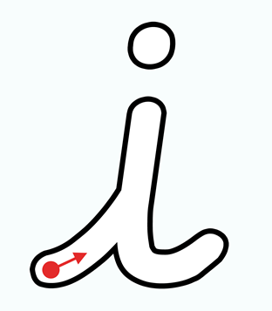

|  |  |
| --- | --- |
| i | 1. **Action:** Index finger draws straight line and then a dot for his head 2. **Tune: Oh My Darling Clementine**   /i/-/i/ insect.  /i/-/i/ insect with a dot for her head.  /i/-/i/ insect. /i/-/i/ insect.  She goes flying off again.  **Rhyme:** Move up the insect’s long leg to his head. Then go back down his body and across his other leg to make a flick. |

My name is ________________________________

LG: I can hear and say the /n/ phoneme. I can write the letter shape for the ‘n’ grapheme.

Draw a circle around the things that begin with /n/

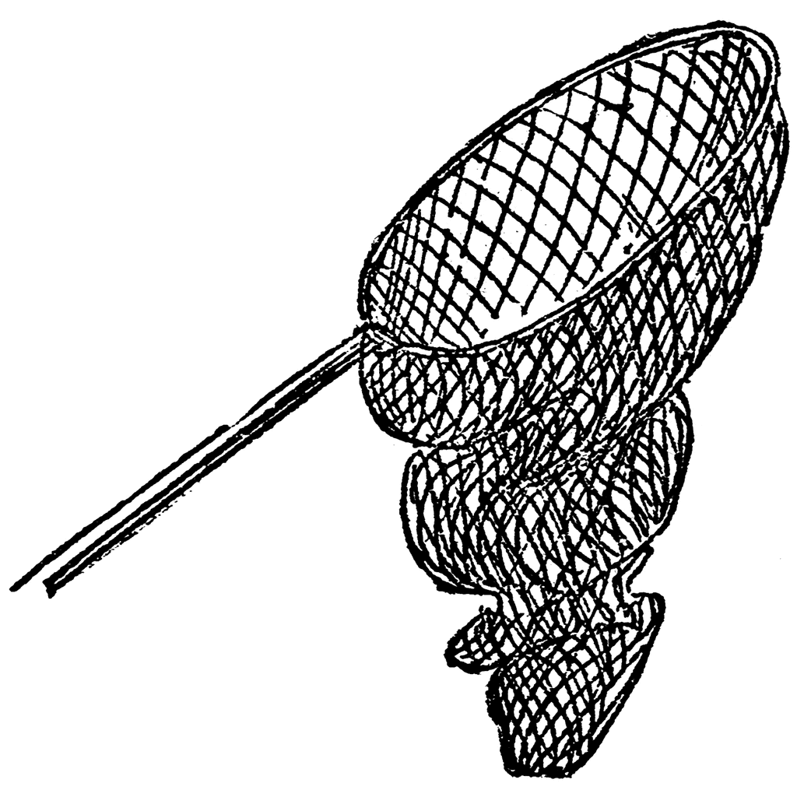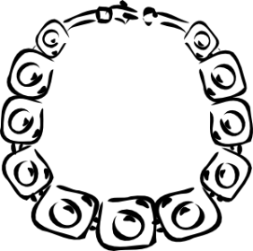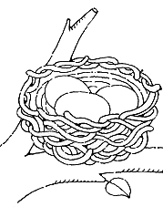



Trace carefully over the dotted lines to show what the nose can smell

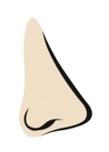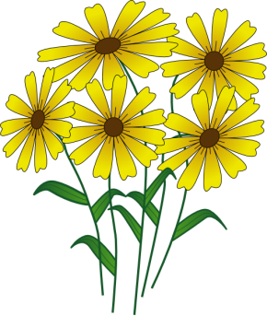



Write the letter shape

|  |  |  |  |  |
| --- | --- | --- | --- | --- |
|  |  |  |  |  |
| n | n | n | n |  |

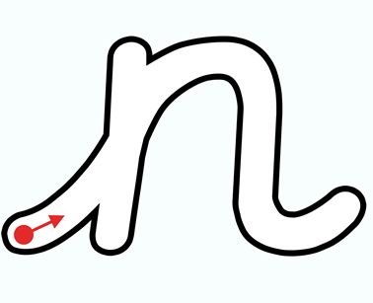

|  |  |
| --- | --- |
| n | 1. **Action:** Pretend to hold a net in your right hand and make a swooping action 2. **Tune: Skip to My Lou**   Fish with a net /n/-/n/-/n/.  Fish with a net /n/-/n/-/n/.  Fish with a net /n/-/n/-/n/.  Look I’ve caught a newt …/n/!  **Rhyme:** Zoom up to the goalkeeper’s head and then down to his boots. Go up to the top of the net, across the top and down the other side. End with a flick, like a footballer’s kick! |

My name is ________________________________

LG: I can hear and say the /m/ phoneme. I can write the letter shape for the ‘m’ grapheme.

Draw a circle around the things that begin with /m/

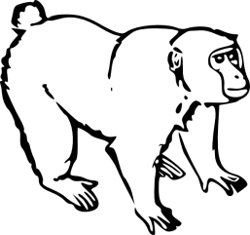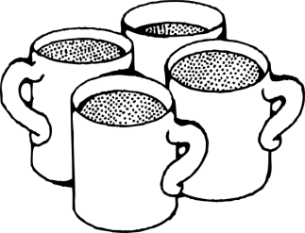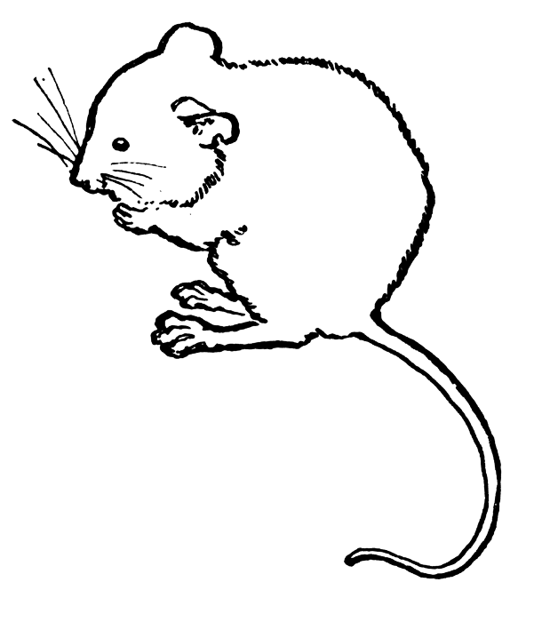

Trace carefully over the dotted lines to help the mole find his home

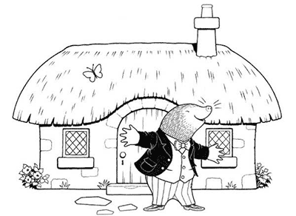

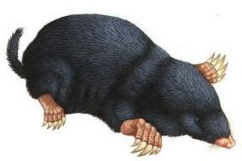

Write the letter shape

|  |  |  |  |  |
| --- | --- | --- | --- | --- |
|  |  |  |  |  |
| m | m | m | m |  |



|  |  |
| --- | --- |
| m | 1. **Action:** Use your right hand to draw a mountain shape from right to left 2. **Tune: Skip to My Lou**   March, march over the mountain.  March, march over the mountain.  March, march over the mountain.  With a /m/-/m/-/m/-/m/-/m/!  **Rhyme:** Climb up and over the first mountain. Then go up and over the next one and end with a flick. |

My name is ________________________________

LG: I can hear and say the /d/ phoneme. I can write the letter shape for the ‘d’ grapheme.

Draw a circle around the things that begin with /d/

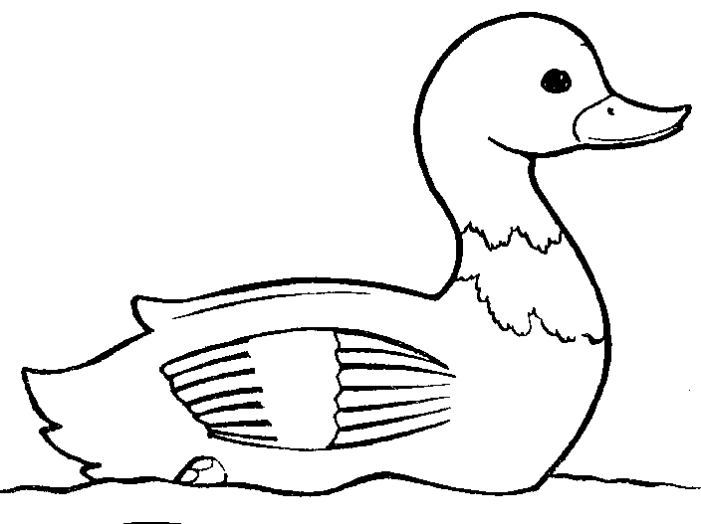

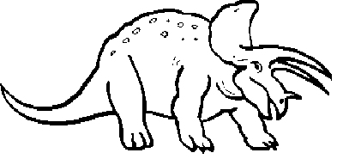

Trace carefully over the dotted lines to show how the dolphins swim

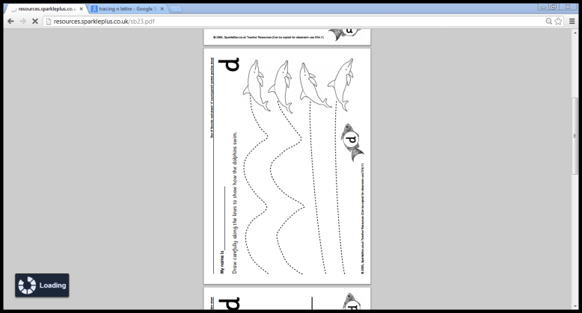

Write the letter shape

|  |  |  |  |  |
| --- | --- | --- | --- | --- |
|  |  |  |  |  |
| d | d | d | d | d |



|  |  |
| --- | --- |
| d | 1. **Action:** Make wide arms for ‘big’ and tall arms for ‘tall’ 2. **Tune: This Old Man**   /d/-/d/-/d/ dinosaur.  This dinosaur is big and tall.  With a /d/-/d/-/d/-/d/ dinosaur.  This dinosaur is big and tall.  **Rhyme:** Climb up on the dinosaur’s back then slide around to his feet. Zoom up to his head then back down and end with a flick. |

My name is ________________________________

LG: I can hear and say the /g/ phoneme. I can write the letter shape for the ‘g’ grapheme.

Draw a circle around the things that begin with /g/

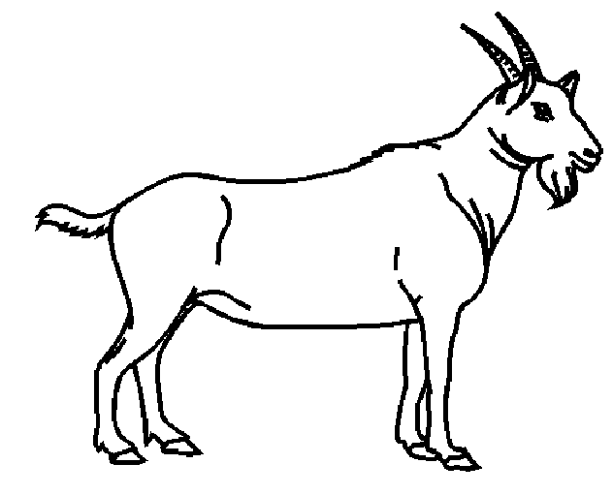

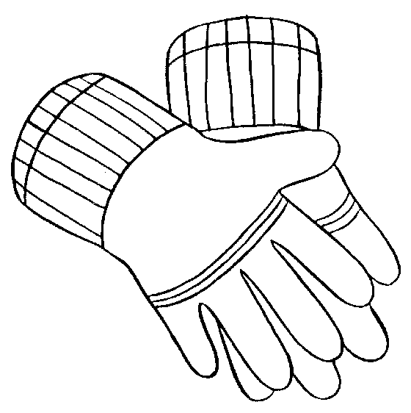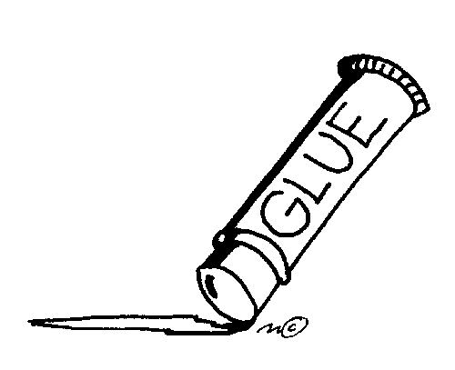



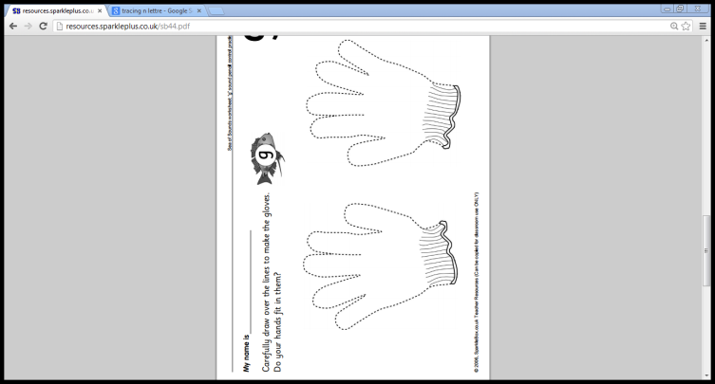

Trace carefully over the dotted lines to make the gloves

Write the letter shape

|  |  |  |  |  |
| --- | --- | --- | --- | --- |
|  |  |  |  |  |
| g | g | g | g | g |



|  |  |
| --- | --- |
| g | 1. **Action:** Use your right index finger to draw a smile under your chin and L-R 2. **Tune: Jimmy Crack Corn**   The girl gives a grin when you tickle her chin.  The girl gives a grin when you tickle her chin.  The girl gives a grin when you tickle her chin.  With a /g/-/g/-/g/-/g/-/g/.  **Rhyme:** Go up and over the top of the girl’s head, then back around her face. Slide all the way down her long plait and make a loop. |

My name is ________________________________

LG: I can hear and say the /o/ phoneme. I can write the letter shape for the ‘o’ grapheme.

Draw a circle around the things that begin with /o/

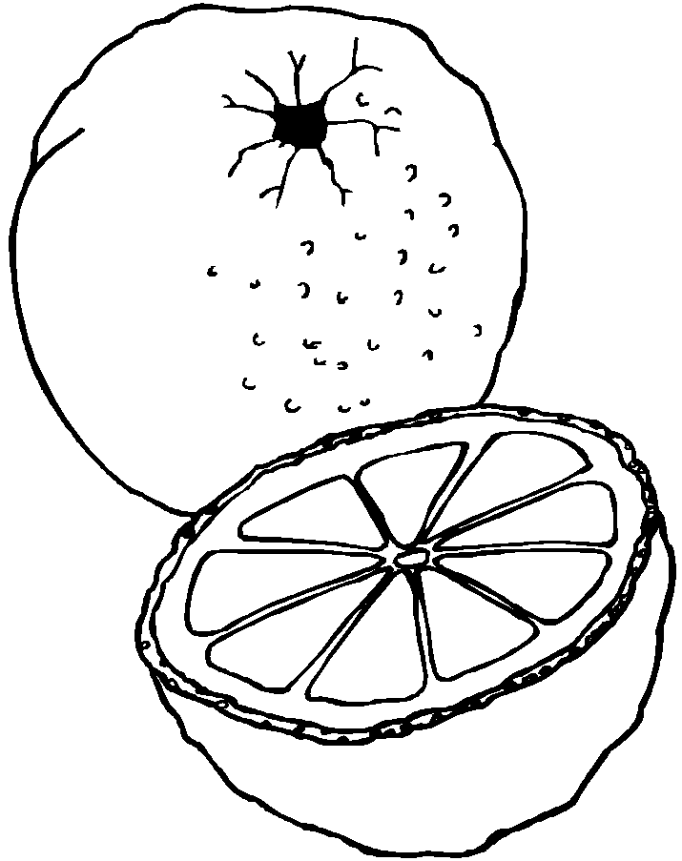





Trace carefully over the dotted lines to show the waves



Write the letter shape

|  |  |  |  |  |
| --- | --- | --- | --- | --- |
|  |  |  |  |  |
| o | o | o | o |  |



|  |  |
| --- | --- |
| o | 1. **Action:** Use your right hand to pretend to squeeze an orange on the right-hand side of your mouth 2. **Tune: Skip to My Lou**   /o/-/o/ squeeze the orange.  /o/-/o/ squeeze the orange.  /o/-/o/ squeeze the orange.  Squeeze the orange like this …/o/!  **Rhyme:** Curl up to the top of the orange and then curve all the way back around to the top. Add a flick. |

My name is ________________________________

LG: I can hear and say the /c/ phoneme. I can write the letter shape for the ‘c’ grapheme.

Draw a circle around the things that begin with /c/

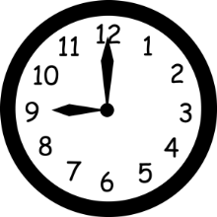

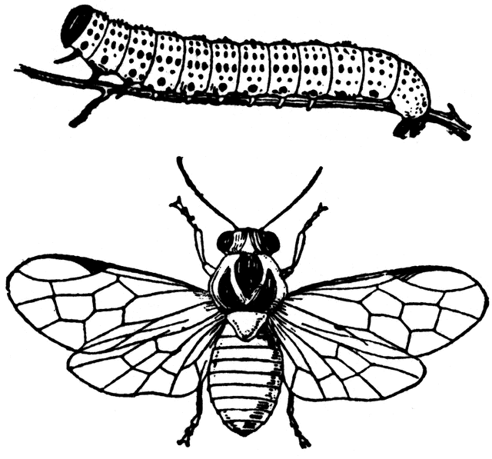

Trace carefully over the dotted lines to help the crabs find their friends

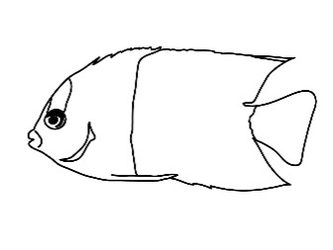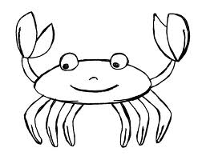







Write the letter shape

|  |  |  |  |  |
| --- | --- | --- | --- | --- |
|  |  |  |  |  |
| c | c | c | c |  |

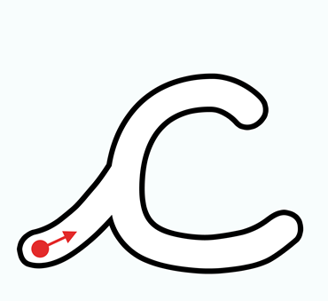

|  |  |
| --- | --- |
| c | 1. **Action:** Use your left hand and rock it forwards and back, forming the top curve of the ‘c’ 2. **Tune:** [**She'll Be Coming 'Round the Mountain**](http://en.wikipedia.org/wiki/She'll_Be_Coming_'Round_the_Mountain)   The caterpillar curls around the /c/-/c/c/.  The caterpillar curls around the /c/-/c/c/.  She curls her body round. She curls her body round.  Yes the caterpillar curls around the /c/-/c/c/.  **Rhyme:** Curl up and over to the caterpillar’s head. Slide all the way around to his tail. |

My name is ________________________________

LG: I can hear and say the /c/ phoneme. I can write the letter shape for the ‘k’ grapheme.

Draw a circle around the things that begin with /c/ as ‘k’

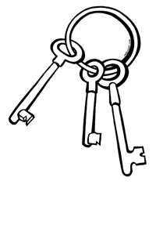

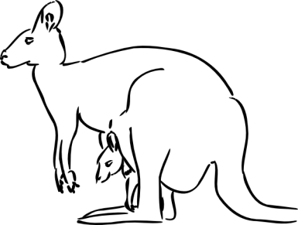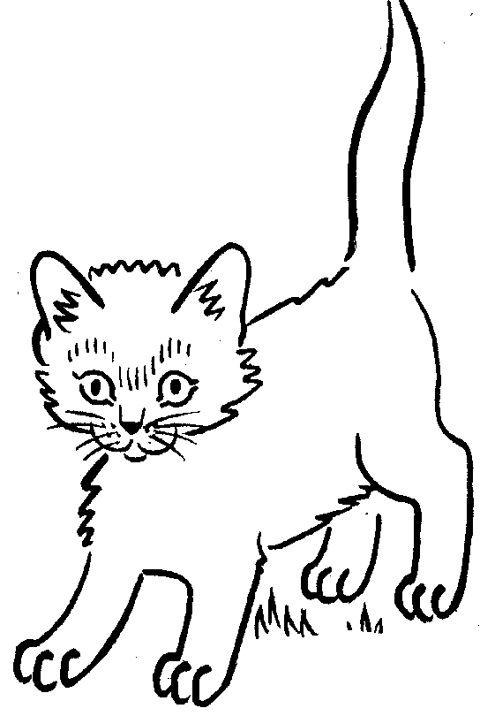

Trace carefully over the dotted lines to unlock the door

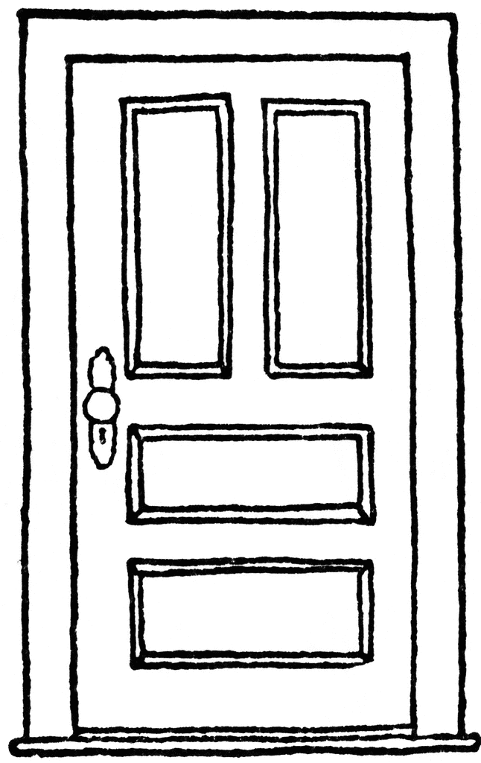



Write the letter shape

|  |  |  |  |  |
| --- | --- | --- | --- | --- |
|  |  |  |  |  |
| k | k | k | k | k |



|  |  |
| --- | --- |
| k | 1. **Action:** Use left hand as a platform. Flick your right index finger and pretend that it is a kicking leg. 2. **Tune:** [**She'll Be Coming 'Round the Mountain**](http://en.wikipedia.org/wiki/She'll_Be_Coming_'Round_the_Mountain)   The king is kicking out his leg /k/-/k/-/k/.  The king is kicking out his leg /k/-/k/-/k/.  He is kicking out his leg. Kicking out his leg.  He is kicking out his leg /k/-/k/-/k/.  **Rhyme:** Jump up to the kangaroo’s head and down to the bottom. Bounce back up to his tummy. Make a loop down his leg and add a big kick along his tail. |

My name is ________________________________

LG: I can hear and say the /c/ phoneme. I can write the letter shapes for the ‘ck’ grapheme.

Draw a circle around the things that have /c/ as ‘ck’ in the middle or at the end

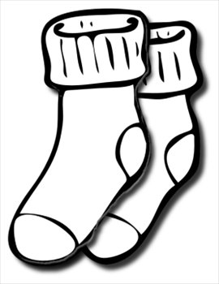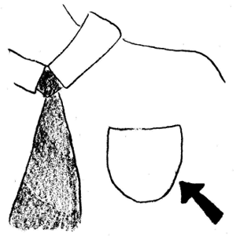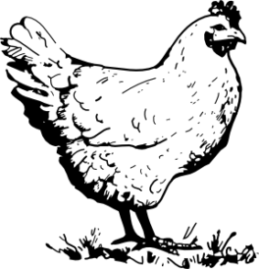



Trace carefully over the dotted lines to help the duck find his pond





Write the letter shape

|  |  |  |
| --- | --- | --- |
| **ck** | **ck** | **ck** |
| ck | ck | ck |

|  |  |
| --- | --- |
| c | 1. **Action:** Use your left hand and rock it forwards and back, forming the top curve of the ‘c’ 2. **Tune:** [**She'll Be Coming 'Round the Mountain**](http://en.wikipedia.org/wiki/She'll_Be_Coming_'Round_the_Mountain)   The caterpillar curls around the /c/-/c/c/.  The caterpillar curls around the /c/-/c/c/.  She curls her body round. She curls her body round.  Yes the caterpillar curls around the /c/-/c/c/.  **Rhyme:** Curl up and over to the caterpillar’s head. Slide all the way around to his tail. |
| k | 1. **Action:** Use left hand as a platform. Flick your right index finger and pretend that it is a kicking leg. 2. **Tune:** [**She'll Be Coming 'Round the Mountain**](http://en.wikipedia.org/wiki/She'll_Be_Coming_'Round_the_Mountain)   The king is kicking out his leg /k/-/k/-/k/.  The king is kicking out his leg /k/-/k/-/k/.  He is kicking out his leg. Kicking out his leg.  He is kicking out his leg /k/-/k/-/k/.  **Rhyme:** Jump up to the kangaroo’s head and down to the bottom. Bounce back up to his tummy. Make a loop down his leg and add a big kick along his tail. |

**ck**

My name is ________________________________

LG: I can hear and say the /e/ phoneme. I can write the letter shape for the ‘e’ grapheme.

Draw a circle around the things that begin with /e/



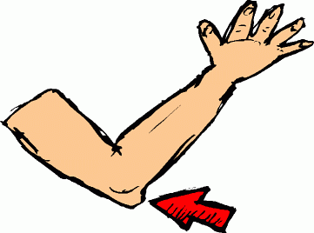

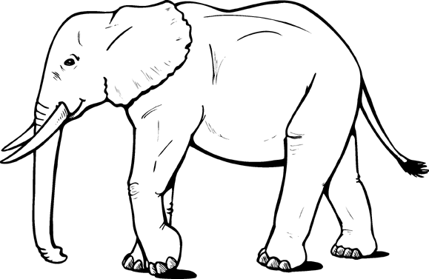

Trace carefully over the dotted lines to decorate these envelopes





Write the letter shape

|  |  |  |  |  |
| --- | --- | --- | --- | --- |
|  |  |  |  |  |
| e | e | e | e |  |



|  |  |
| --- | --- |
| e | 1. **Action:** Pretend to tap an egg on the side of a pan and crack it into the pan 2. **Tune: Skip to My Lou**   Eggs in the pan /e/-/e/-/e/.  Eggs in the pan /e/-/e/-/e/.  Eggs in the pan /e/-/e/-/e/.  Crack the egg like this …/e/!  **Rhyme:** Slide up and make a loop to put the fried egg in. Curl back down with a flick. |

My name is ________________________________

LG: I can hear and say the /u/ phoneme. I can write the letter shape for the /u/ grapheme.

Draw a circle around the things that begin with /u/

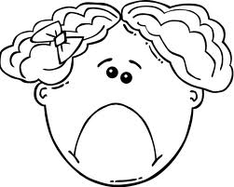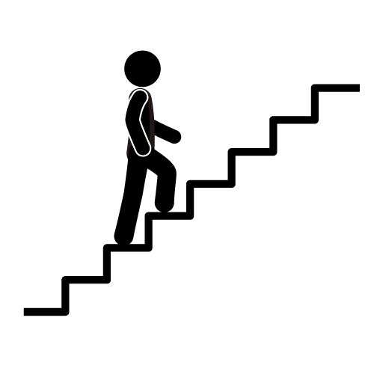



Trace carefully over the dotted lines to show how the rain falls

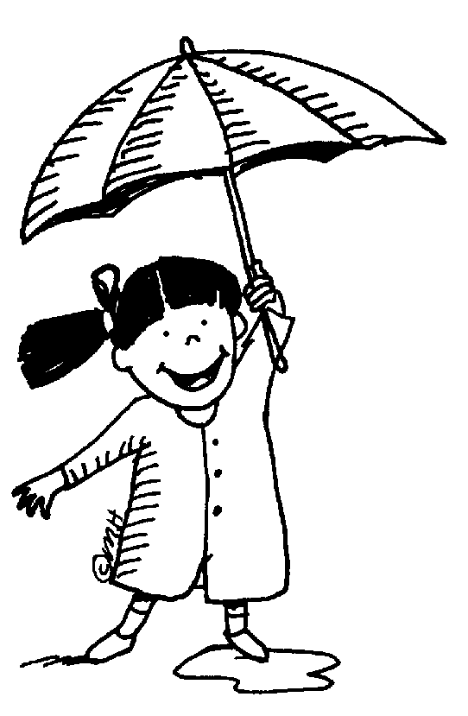

Write the letter shape

|  |  |  |  |  |
| --- | --- | --- | --- | --- |
|  |  |  |  |  |
| u | u | u | u | u |



|  |  |
| --- | --- |
| u | 1. **Action:** Pretend to open an umbrella 2. **Tune: Skip to My Lou**   /u/-/u/ up go umbrellas.  /u/-/u/ up go umbrellas.  /u/-/u/ up go umbrellas…  …when it starts to rain!  **Rhyme:** Move up to the top of the line and then make a curve around the umbrella. Go back up to the top and down to make a flick. |

My name is ________________________________

LG: I can hear and say the /r/ phoneme. I can write the letter shape for the ‘r’ grapheme.

Draw a circle around the things that begin with /r/



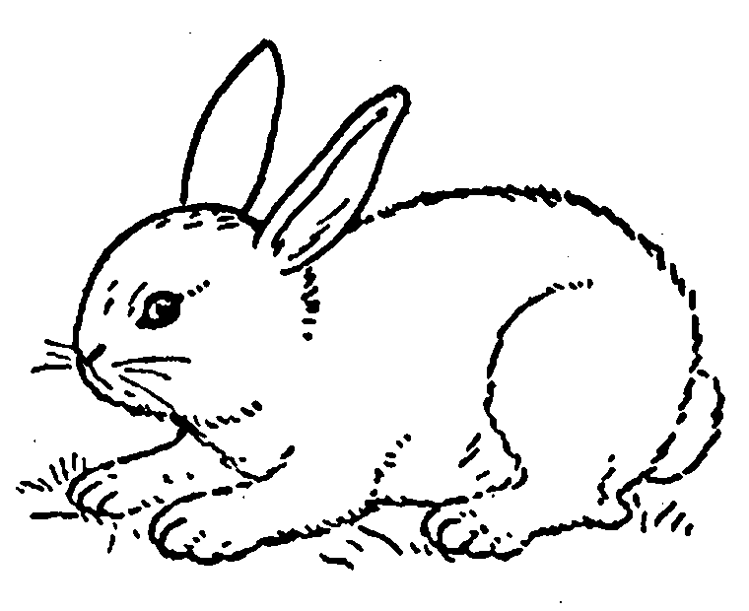

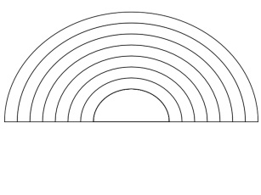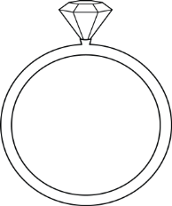

Trace carefully over the dotted lines to show how the stingrays swim







Write the letter shape

|  |  |  |  |  |
| --- | --- | --- | --- | --- |
|  |  |  |  |  |
| r | r | r | r | r |



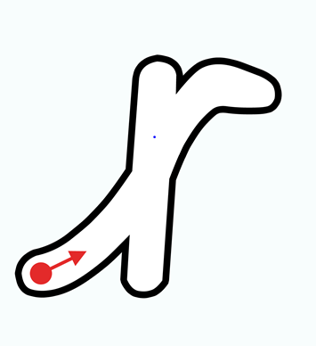

|  |  |
| --- | --- |
| r | 1. **Action:** Move both arms and pretend to run like a robot 2. **Tune: Run Rabbit Run**   Run robot, run robot, run, run, run.  Run robot, run robot, run, run, run.  Raise your arms high to the sky and…  …run robot, run robot, /r/-/r/-/r/  **Rhyme:** Roll up to the robot’s head and all the way down to his wheels. Now go up and over his reached out arm. |

My name is ________________________________

LG: I can hear and say the /h/ phoneme. I can write the letter shape for the ‘h’ grapheme.

Draw a circle around the things that begin with /h/

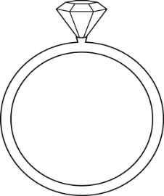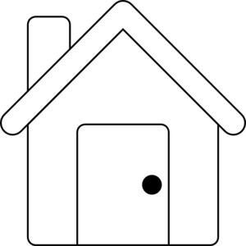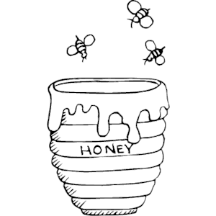

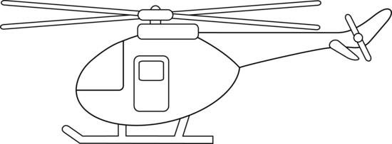

Trace carefully over the dotted lines to show how the helicopters fly

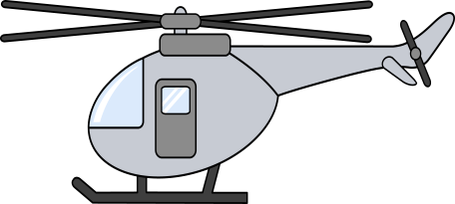



Write the letter shape

|  |  |  |  |  |
| --- | --- | --- | --- | --- |
|  |  |  |  |  |
| h | h | h | h |  |

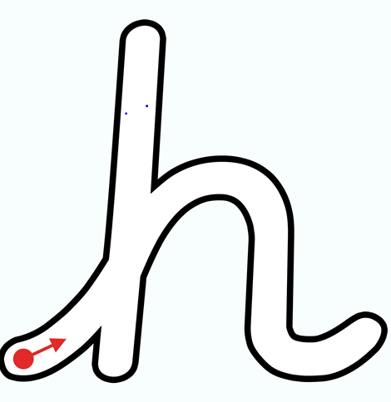

|  |  |
| --- | --- |
| h | 1. **Action:** Move hands up and down to control the horse’s reins 2. **Tune: Skip to My Lou**   Hop on the horse /h/-/h/-/h/  Hop on the horse /h/-/h/-/h/  Hop on the horse /h/-/h/-/h/  Trotting up and down …/h/!  **Rhyme:** Climb up to brush the horse’s head and brush down to his hooves. Go up to brush over his back and all the way to the end of his tail. |

My name is ________________________________

LG: I can hear and say the /b/ phoneme. I can write the letter shape for the ‘b’ grapheme.

Draw a circle around the things that begin with /b/

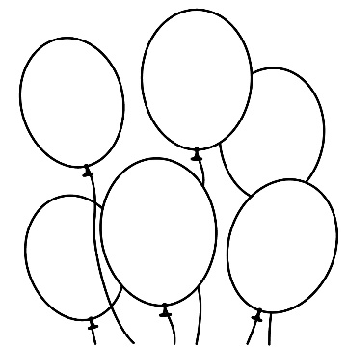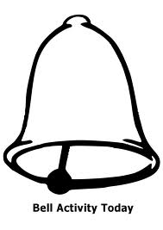

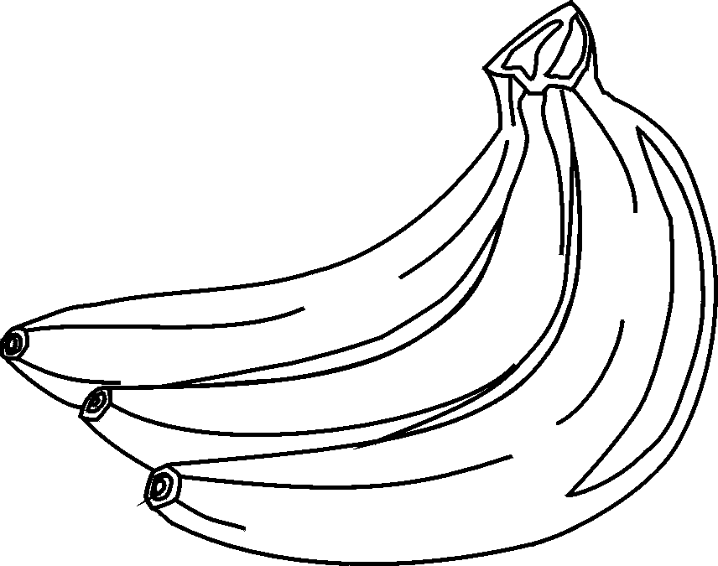

Trace carefully over the dotted lines to show how the balls bounce

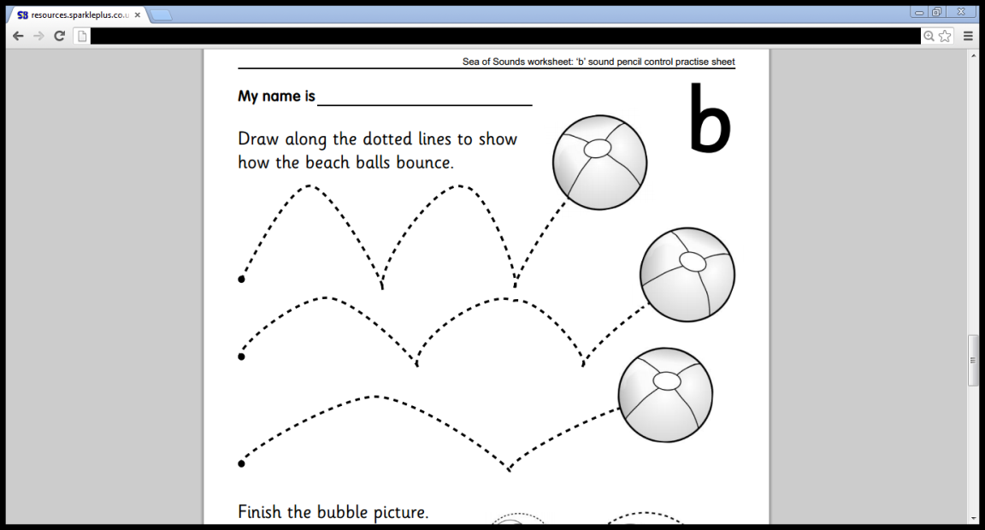

Write the letter shape

|  |  |  |  |  |
| --- | --- | --- | --- | --- |
|  |  |  |  |  |
| b | b | b | b | b |

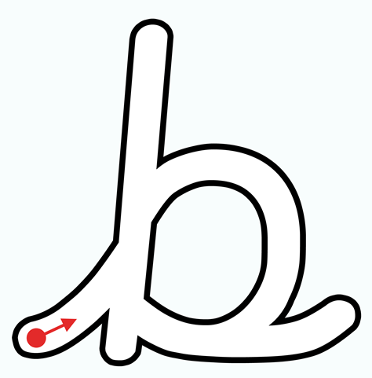

|  |  |
| --- | --- |
| b | 1. **Action:** Use flat hands and stamp down like a boot 2. **Tune: Bring your bat and bring your ball**   Big black boots go walking on /b/-/b/  Big black boots go walking on.  Walk your boots this way …/b/!  **Rhyme:** Up to the top of the boot and all the way down. Go half way back up and whizz around the toe to the heel. Go back across the bottom and end with a flick. |

My name is ________________________________

LG: I can hear and say the /f/ phoneme. I can write the letter shape for the ‘f’ grapheme.

Draw a circle around the things that begin with /f/

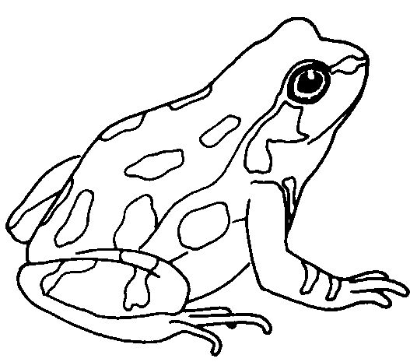

Trace carefully over the dotted lines to finish the firework picture

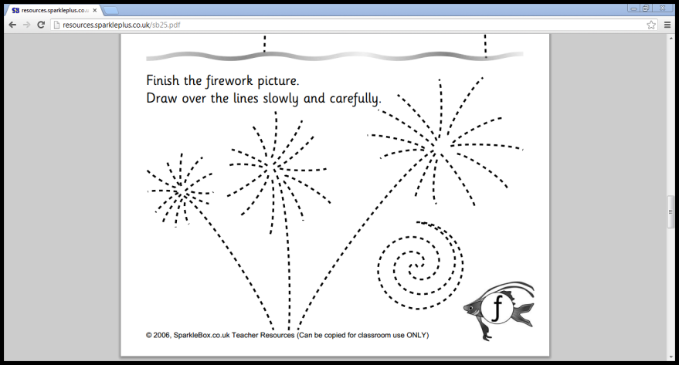

v

Write the letter shape

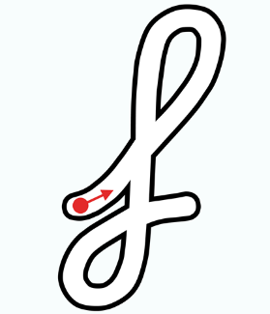

|  |  |  |  |  |
| --- | --- | --- | --- | --- |
|  |  |  |  |  |
| f | f | f | f | f |

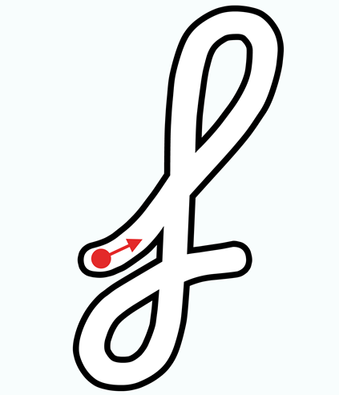

|  |  |
| --- | --- |
| f | 1. **Action:** Pinch right hand fingers and thumb together. Wave them under your nose. 2. **Tune: Oh My Darling Clementine**   Smell the flower, smell the flower.  Oh the fragrance is so strong.  Smell the flower, lovely flower.  /f/-/f/-/f/-/f/-/f/-/f/-/f/  **Rhyme:** Fly like a bee to smell the flower at the top. Then buzz straight down to the bottom. Make a loop and cross over the leaves. |

My name is ________________________________

LG: I can hear and say the /f/ phoneme. I can write the letter shapes for the ‘ff’ grapheme.

Draw a circle around the things that have /f/ as ‘ff’ in the middle or at the end

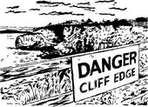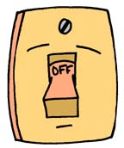

Trace carefully over the dotted lines to draw the cuffs on this shirt

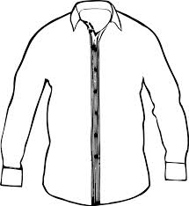

Write the letter shape

|  |  |  |
| --- | --- | --- |
| **ff** | **ff** | **ff** |
| ff | ff | ff |

|  |  |
| --- | --- |
| f | **1.Action:** Pinch right hand fingers and thumb together. Wave them under your nose.  **2. Tune: Oh My Darling Clementine**  Smell the flower, smell the flower.  Oh the fragrance is so strong.  Smell the flower, lovely flower.  /f/-/f/-/f/-/f/-/f/-/f/-/f/  **Rhyme:** Fly like a bee to smell the flower at the top. Then buzz straight down to the bottom. Make a loop and cross over the leaves. |

**ff**

My name is ________________________________

LG: I can hear and say the /l/ phoneme. I can write the letter shape for the ‘l’ grapheme.

Draw a circle around the things that begin with /l/

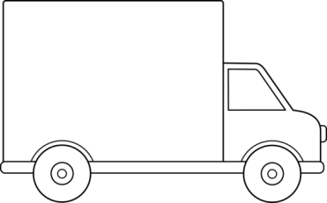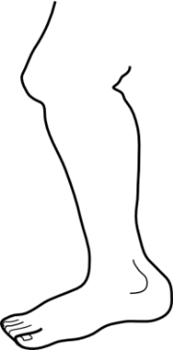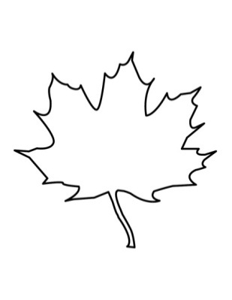

Trace carefully over the dotted lines to show how the ladybirds crawl

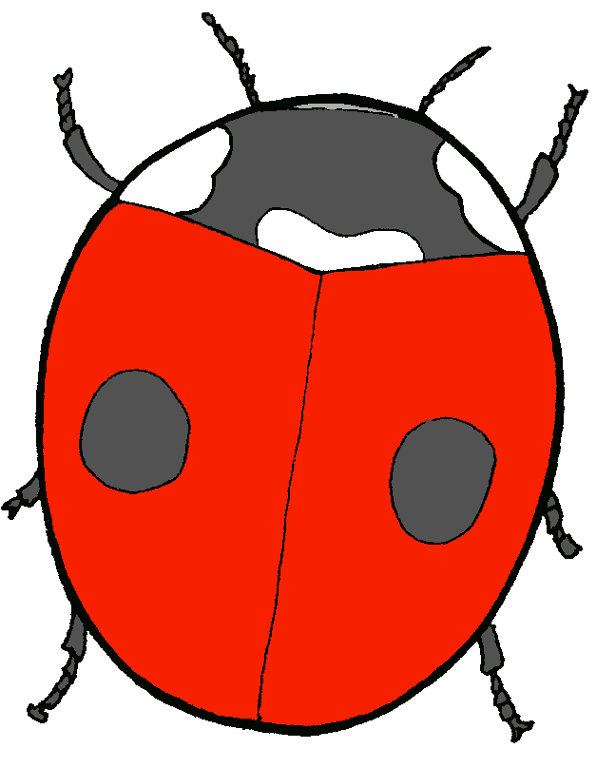





Write the letter shape

|  |  |  |  |  |
| --- | --- | --- | --- | --- |
|  |  |  |  |  |
| l | l | l | l | l |

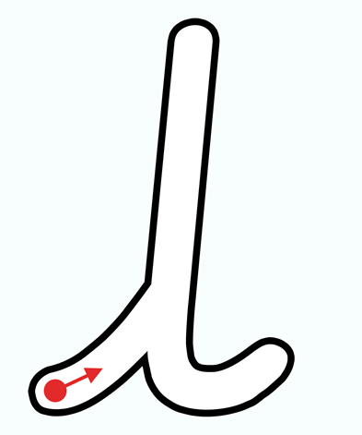

|  |  |
| --- | --- |
| l | 1. **Action:** Use left hand as a platform. Use your right index finger and middle finger to walk across the hand. 2. **Tune: Frere Jacques**   Long legs walking, long legs walking.  /l/-/l/-/l/ /l/-/l/-/l/  Walking fast and slowly, walking fast and slowly.  /l/-/l/-/l/ /l/-/l/-/l/  **Rhyme:** Slide up to the top of this long leg, then straight back down to the foot. End with a flick. |

My name is ________________________________

LG: I can hear and say the /l/ phoneme. I can write the letter shapes for the ‘ll’ grapheme.

Draw a circle around the things that have /l/ as ‘ll’ at the end of the word

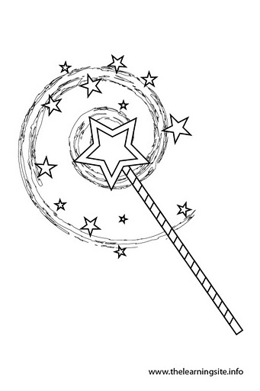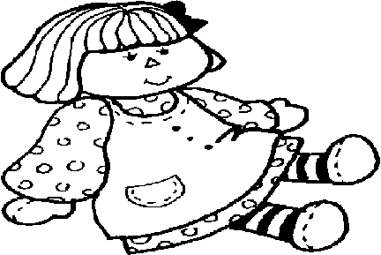



Trace carefully over the dotted lines to cast the spell

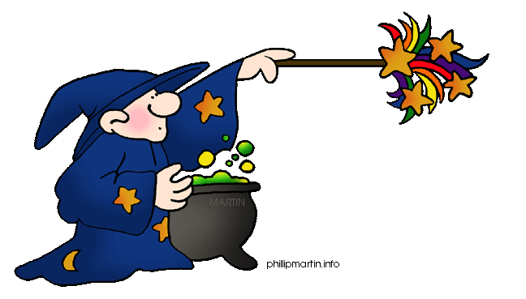

Write the letter shape

|  |  |  |
| --- | --- | --- |
| **ll** | **ll** | **ll** |
| ll | ll | ll |

**ll**

|  |  |
| --- | --- |
| l | 1. **Action:** Use left hand as a platform. Use your right index finger and middle finger to walk across the hand. 2. **Tune: Frere Jacques**   Long legs walking, long legs walking.  /l/-/l/-/l/ /l/-/l/-/l/  Walking fast and slowly, walking fast and slowly.  /l/-/l/-/l/ /l/-/l/-/l/   1. **Rhyme:** Slide up to the top of this long leg, then straight back down to the foot. End with a flick. |

My name is ________________________________

LG: I can hear and say the /s/ phoneme. I can write the letter shapes for the ‘ss’ grapheme.

Draw a circle around the things that have /s/ as ‘ss’ at the end of the word

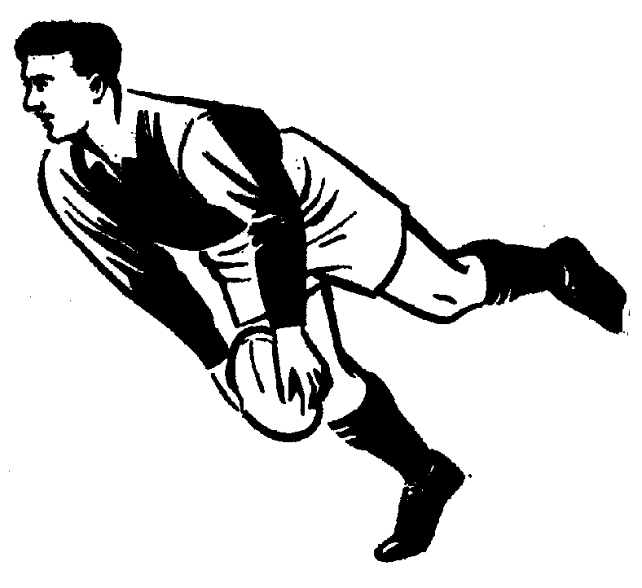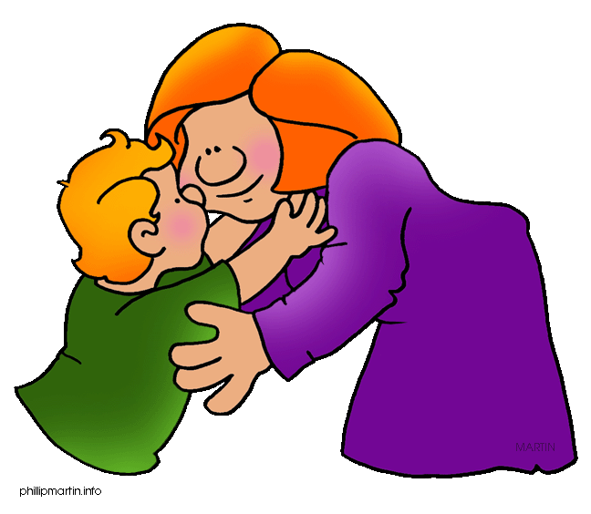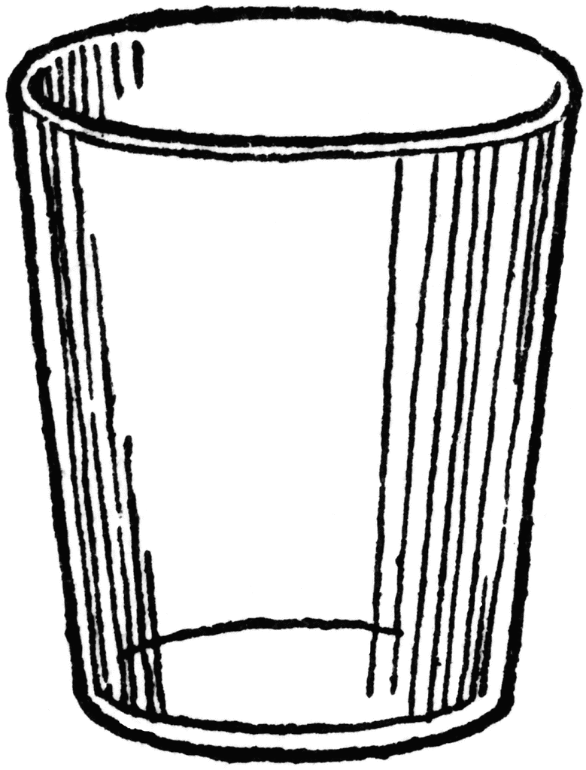

Trace carefully over the dotted lines to draw the outline of her dress

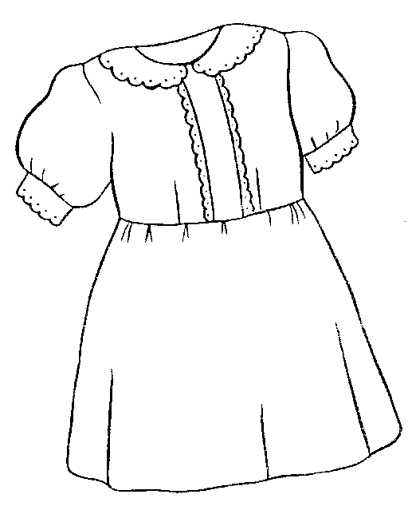

Write the letter shape

|  |  |  |
| --- | --- | --- |
| **ss** | **ss** | **ss** |
| ss | ss | ss |

**ss**

|  |  |
| --- | --- |
| s | 1. **Action:** Weave hand in an s shape 2. **Tune:** **The Farmer’s in his Den**   The snake is in the grass.  The snake is in the grass.  /sss/ /sss/  The snake is in the grass.   1. **Rhyme:** Slide up and over to the snake’s long tongue. Watch out! Slide all the way round to his tail and then across the bottom to make a flick. |