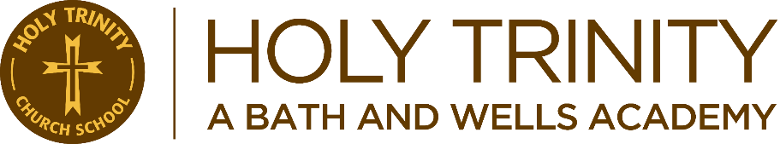
Learning, Achieving and Flourishing Together in God’s Promises, Goodness and Love.
English

Curriculum Segments

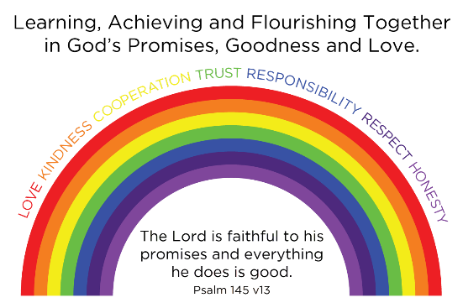
Integrated
Science
History
Geography
Design and Technology
Art
Mathematics
Writing
Computing
Music

Mathematics

Discrete
Computing
Music
MFL

PSHE
RE
PE
Learning
- To understand about the range of relationships, developing a sense of personal identity and emotional awareness
- To learn about our bodies, looking after them and keeping healthy and safe
Achieving
- To have confidence, respect for others and self-esteem, whilst having the strategies and social skills to flourish in relationships
Flourishing
- To have a good understanding of our own and others’ mental health and wellbeing.
- To understand what it means to be part of a community, within and outside of school.
Together in God’s Promises, Goodness and Love
- To develop respect and tolerance for others, being sensitive to how others may respond, whilst also understanding the role technology and the media plays in our society,

Religious Education
Learning
- To enable all our children to have a deeper understanding of Christianity and different faiths.
Achieving
- To listen to and respect others’ opinions and values, building a positive and accepting mind set.
Flourishing
- To provide a caring, respectful environment, linking into our ‘Rainbow Values’ in which every child feels empowered to explore, reflect on and question their own beliefs and those of others.

Together in God’s Promises, Goodness and Love
- To encourage the experience of Christian life and worship, providing a foundation in, and understanding of, Christianity.

Integrated Subjects:
Learning:
- To inspire children’s curiosity and fascination about the world, its people and cultures, historical events and the arts.
Achieving:
- A fluidity of core and foundation subjects will provide children with essential skills that they will then extract and applying to meaningful cross-curricular activities.
Flourishing:
- To support children in the development of their sense of identity and where they fit in the world
Together in God’s Promises, Goodness and Love
- Children to developing creative minds/thinking and independence

Discrete Subjects:
Learning:
- To develop musical, language and computing skills that provide strong equality of opportunities.
Achieving:
- To develop musical, language and computing skills that can be transferred to other subjects and opportunities.
Flourishing:
- To allow children to explore a wider range of subjects independently to foster their imagination.
Together in God’s Promises, Goodness and Love
- Children to develop creative minds/thinking and independence.

Curriculum:
Learning:
  - To enable all our children to possess transferable skills to make positive progress in all curriculum areas.
Achieving:
  - To instil high aspirations in all our children, building a positive mind set and a sense of belonging by tailoring to our children’s needs.
Flourishing:
  - To enable our children to flourish in all areas of our enriched curriculum creating positive school memories.
Together in God’s Promises, Goodness and Love
  - Children to feel confident at expressing their beliefs and to have an awareness and sensitivity of diversity that will enable them to succeed in our modern world.

Physical Educational and Physical Well-Being
Learning:
- To enable all children to possess a range of gross and fine motor skills including to confidently swim, in a range of strokes, over a distance of 25m or greater by the end of year 6.
Achieving:
- For children to develop a positive sense of personal identity and to have the self-confidence to try their best no matter their ability.
Flourishing:
- To recognise the importance of how physical activity can positively affect physical and mental health.
Together in God’s Promises, Goodness and Love:
- Children to have an awareness and sensitivity of differing abilities using a wider range of interpersonal skills (resilience, perseverance, respect, co-operation, trust) that will enable them to succeed as an individual or as part of a team (sportsmanship).
Mathematics
Learning:
- Children develop a wide range of mathematical skills that they can then apply to reasoning and problem solving contexts.
Achieving:
- Children to develop the ability to apply mathematical skills to real life situations integrated into other subjects.
Flourishing
- Children are inspired to understand that all children can learn and achieve in mathematics.
Together in God’s Promises, Goodness and Love
- Children to develop a Wonder of Numbers through opportunities to consider a spiritual and philosophical dimension to the subject, allowing the children to reflect upon experiences of awe, compassion, beauty.
English:
Learning:
- Children develop skills in composition, grammar, reading, phonics, spelling and speaking and listening through learning journeys that are imaginative, engaging, relevant and purposeful.
Achieving:
- Children to become self-directed, reflective and critical learners, rejecting and pursue ideas in more depth and then defend their ideas developing their metacognitive capacity in the process.
Flourishing:
- Through drama and storytelling, art, discussion, drawing and dance, children are engaged in literacy practices that make the world around them meaningful and imaginatively satisfying to them. Children are exposed to reading a wide range of text types, encouraging openness and fostering the enjoyment and the ability to make personal connections and insights through debate, discussion and presentation.
Together in God’s Promises, Goodness and Love
- Children are exposed to the full range of in-class collaborations, and partnerships with parents, authors, poets, storytellers, dancers and other artists and professionals.

